Project screenshots
Dashboard 1: Overall Crime Statistics
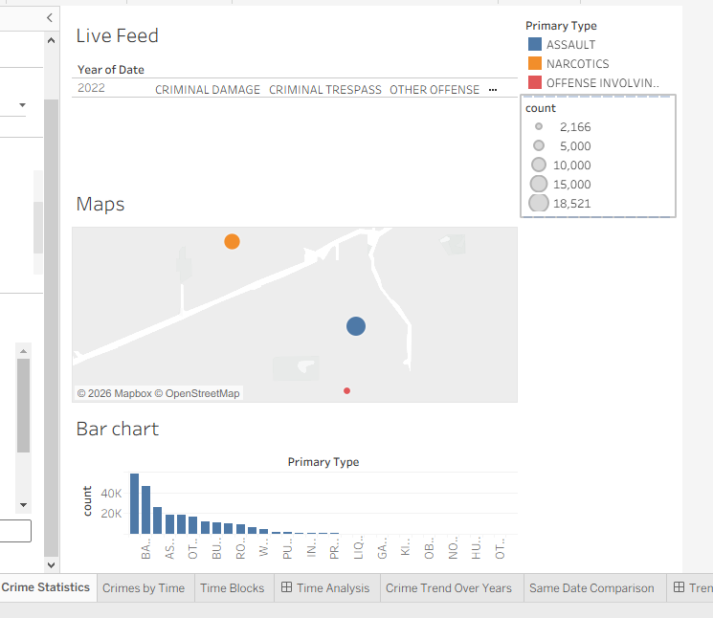
Dashboard 2: Time Analysis

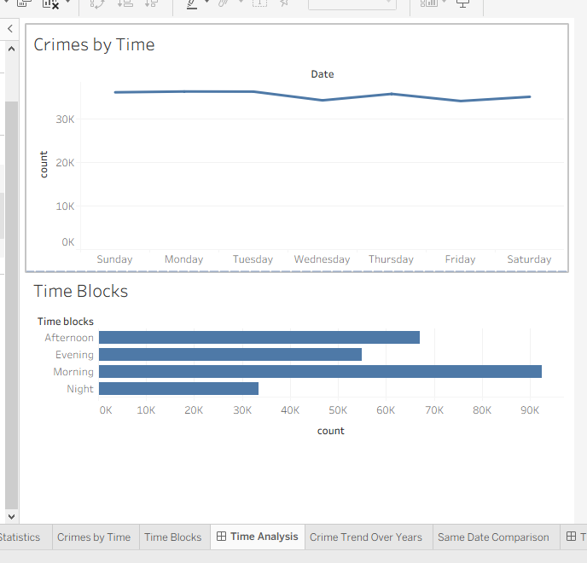
Dashboard 3: Trend Analysis

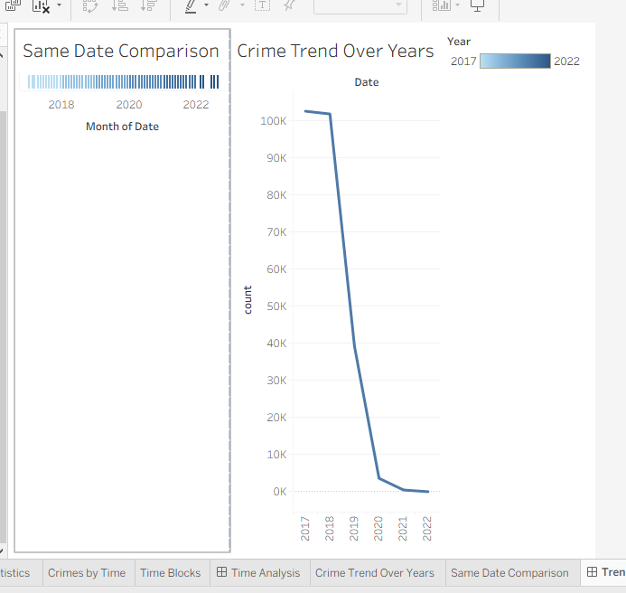
Dashboard 4: Comparative Analysis
